Detecting Automobile Insurance Fraud Using Advanced Machine Learning Techniques

1. Introduction
Insurance fraud is a pervasive issue that plagues the insurance industry, causing financial losses in the order of billions each year. Among the various types of fraudulent activities, automobile insurance fraud is particularly prevalent. This involves policyholders submitting false or exaggerated claims to illicitly gain financial benefits. The complexity and sheer volume of insurance claim data make it challenging to detect such fraudulent activities using traditional methods. In response to this challenge, the focus of this project is to develop a sophisticated machine-learning model capable of effectively identifying fraudulent automobile insurance claims. The successful implementation of such a system holds the potential to empower insurance companies to better manage risks and optimize pricing strategies.
2. Data Analysis and Exploration
Rigorous initial data analysis was conducted to determine if this automobile insurance claims dataset contains reliable signals for training machine learning models to accurately detect fraud.
The provided data file comprises 40 feature columns capturing a multitude of relevant variables across 1000 total records of historical insurance claims. Details include policyholder demographics, insured vehicle attributes, coverage specifics extensive claim details, and crucially the 'fraud_reported' binary target variable indicating proven fraud.
Key dimensions analyzed:
- Feature data types assessment - a mix of numeric, categorical, and free-text variables
- Null value scanning - no significant missing data issues observed
Statistical analysis revealed insights differentiating fraudulent from non-fraudulent claims:
- 247 out of 1000 total records were flagged as fraud, a 24.7% fraudulent claim rate
- Much shorter gap between policy start and fraud claim date
- Markedly heightened fraud claim rate overnight 1 AM-6 AM
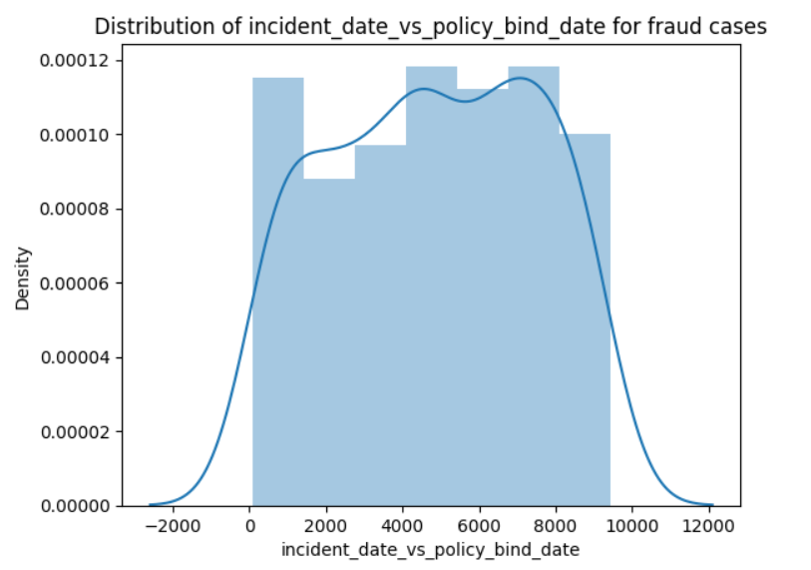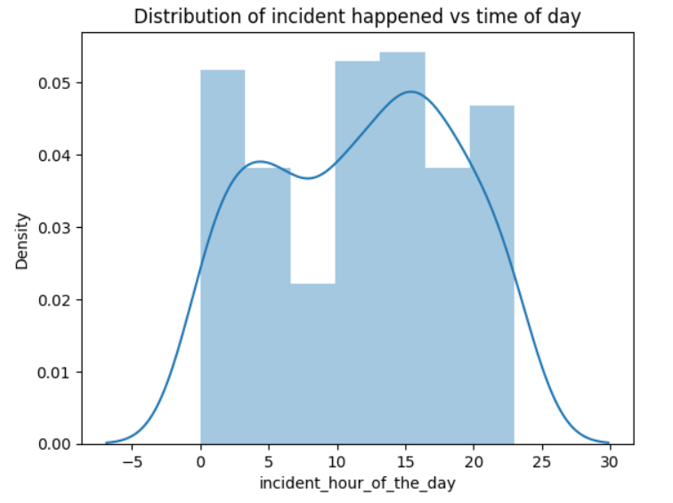
Figures 1 and 2: Figure1- Distribution of incident date vs policy bind date, Figure 2- Distribution of time of day for fraud cases

Additional data adjustments executed:
- Standardized date-time formatting
- Split combined coverage limit variable into lower and upper
Correlation analysis exposed interdependent feature pairs requiring dimensionality reduction.By thoroughly analyzing and summarizing the structure, contents, and statistical trends within this raw automobile insurance claims data, we gained confidence in available fraud signals to leverage toward accurate prediction models.
3. Exploratory Data Analysis (EDA) Concluding Remarks
Our detailed exploration of the dataset using Exploratory Data Analysis (EDA) has been crucial in understanding its complexities and evaluating its suitability for training machine learning models, especially those aimed at detecting insurance fraud reliably.
In the field of machine learning, making informed decisions during model development depends heavily on understanding the dataset's characteristics and statistical trends. The EDA process, as we've carried out, plays a vital role in confirming the dataset's strengths and uncovering potential signals that can guide the necessary preprocessing and feature engineering steps. These steps are crucial before applying advanced machine learning algorithms.
- Fraud Incidence: Analysis of the 'fraud_reported' column revealed that 247 out of 1000 total records were confirmed fraudulent claims, establishing a 25% fraud example rate. This imbalanced distribution is treated using the oversampling technique to avoid any bias in the model fitting and prediction
- Feature Distributions: In-depth examination of feature distributions uncovered discernible patterns distinguishing fraudulent from non-fraudulent data. Notably, instances of fraud exhibited a distinct peak during the late-night hours, specifically from 1 AM to 6 AM. Additionally, a significantly shorter time lag between policy start and claim date was observed in fraudulent cases, providing potential behavioral nuances for predictive modeling.
- Data Quality Assurance: A noteworthy revelation was the absence of material data quality issues. There were no significant missing values or erroneous data that required immediate remediation. Minor adjustments, such as standardizing date-time formatting and splitting composite fields, were applied to enhance data integrity.
- Correlation Analysis: Delving into correlation analysis revealed feature pairs with dangerously high collinearity. Recognizing the risks of model instability, dimensions requiring reduction were identified for subsequent stages, ensuring a streamlined and efficient modeling process.
In conclusion, the success of machine learning initiatives hinges on the confirmation of viable signals within quality data before embarking on intensive workflows. Our comprehensive EDA phase has unequivocally marked the dataset with the seal of reliability, equipped with indicators and examples crucial for training sophisticated models.
4. Pre-processing Pipeline
The pre-processing pipeline involved a sequence of steps designed to enhance the quality and suitability of the data for machine learning model training:
The preprocessing pipeline is a crucial phase in the machine learning workflow where the raw data is transformed, cleaned, and prepared for training models. In the context of the insurance claim fraud detection project, the preprocessing pipeline consisted of several key steps:
- Conversion of Categorical Features to Numeric Using Label Encoding
  - Objective: Many machine learning algorithms require numerical input, so categorical features, which represent qualitative data, need to be converted.
  - Procedure: Label encoding assigns a unique numeric identifier to each category in a categorical feature. This allows the algorithm to work with these features effectively.
- Oversampling Minority Positive Fraud Class to Balance Training Data
  - Objective: Imbalanced datasets, where one class (in this case, fraudulent claims) is underrepresented, can lead to biased model training. Oversampling is a technique used to balance the class distribution.
  - Procedure: Randomly duplicating instances of the minority class or generating synthetic instances (using techniques like SMOTE - Synthetic Minority Over-sampling Technique) helps balance the number of positive and negative instances.
- Removing Outliers using IQR method
  - Objective: Outliers, which are data points significantly different from the majority of the data, can distort model training and predictions. Removing outliers helps improve model robustness.
  - Procedure: The Interquartile Range (IQR) method involves identifying the range between the first and third quartiles of the data. Data points outside this range are considered outliers and are removed.
- Standard Scaling of Continuous Variables
  - Objective: Machine learning algorithms are sensitive to the scale of input features. Standard scaling ensures that all features have a mean of 0 and a standard deviation of 1.
  - Procedure: Each continuous variable is transformed by subtracting the mean and dividing by the standard deviation.
- Dimensionality Reduction After Identifying Features with High Collinearity Through VIF
  - Objective: High collinearity (correlation) among features can lead to redundancy and adversely affect model performance. Dimensionality reduction is performed to retain only essential features.
  - Procedure: Variance Inflation Factor (VIF) is a metric used to identify the degree of multicollinearity. Features with high VIF values are considered for removal to reduce redundancy and improve model efficiency.

By implementing these preprocessing steps, the raw automobile insurance claims data was refined into a format suitable for training machine learning models. Each step addresses specific challenges associated with the data, ensuring that the models are more robust, less prone to biases, and capable of generalizing well to new, unseen data. The choice of preprocessing techniques depends on the nature of the data and the requirements of the machine learning algorithm being used.
The utilization of cross-validation throughout the model development process ensured the robustness of the models to variations in training/test data splits.

5. Building Machine Learning Models
In the pursuit of developing an effective automobile insurance fraud detection system, various machine learning models were employed and evaluated. This section provides a detailed breakdown of the performance metrics for each model, aiding in the understanding of their strengths and weaknesses.
Logistic Regression
- Accuracy: 86.12%
- Precision: 0.88 (fraud), 0.85 (not fraud)
- Recall: 0.83 (fraud), 0.89 (not fraud)
- F1-score: 0.86
Logistic Regression established a solid baseline with balanced performance. The precision, recall, and F1-score metrics indicate an overall competitive performance. However, the model's accuracy falls behind most of oth
Random Forest
- Accuracy: 89.68%
- Precision: 0.90 for both classes
- Recall: 0.89 (not fraud), 0.90 (fraud)
- F1-score: 0.90
Random Forest exhibited a significant performance gain over Logistic Regression, leveraging ensemble model averaging effects. The model's high accuracy, precision, and recall for both classes make it a robust choice for fraud detection. However, Gradient Boosting, another ensemble method, surpassed its overall performance.
SVC (Support Vector Classification)
- Accuracy: 88.26%
- Precision: 0.88 for both classes
- Recall: 0.88 (not fraud), 0.89 (fraud)
- F1-score: 0.88
SVC, known for handling complex variable interactions, demonstrated effectiveness but did not achieve the top results. While its accuracy and precision are commendable, Gradient Boosting outperformed it in various metrics.
Gradient Boosting (GBM)
- Accuracy: 89.32%
- Precision: 0.90 (not fraud), 0.89 (fraud)
- Recall: 0.88 (not fraud), 0.90 (fraud)
- F1-score: 0.89
Gradient Boosting emerged as the highest-performing model, showcasing superior accuracy, precision, recall, and F1-score. Its effectiveness was further amplified through hyperparameter optimization, solidifying its position as the model of choice for fraud detection in this project.
AdaBoost
- Accuracy: 85.05%
- Precision: 0.82 (not fraud), 0.88 (fraud)
- Recall: 0.88 (not fraud), 0.82 (fraud)
- F1-score: 0.85
AdaBoost yielded respectable results, but its performance was slightly overshadowed by Gradient Boosting. The model demonstrated a tendency to overfit more than some other methods tested, emphasizing the importance of finding the right balance between complexity and generalization.

Bagging Classification
- Accuracy: 87.19%
- Precision: 0.89 (not fraud), 0.86 (fraud)
- Recall: 0.85 (not fraud), 0.90 (fraud)
- F1-score: 0.87
The Bagging Ensemble approach, leveraging bootstrap sampling, proved effective but fell behind the top-performing Gradient Boosting model. While it delivered competitive results, the model did not surpass the comprehensive performance achieved by Gradient Boosting.

Extra Tree Classifier
- Accuracy: 69.3%
- Precision: 0.69 (not fraud), 6.86 (fraud)
- Recall: 0.67 (not fraud), 0.71 (fraud)
- F1-score: 0.68
Extra Tree Classifier comes with the least-performing classification model among the others.
Cross-Validation Evaluation
Rigorous cross-validation was conducted to assess model sensitivity across 5 randomized train/test splits for more reliable real-world accuracy estimation.
Logistic Regression
- CV Accuracy: 79.1%
- Hold-out Accuracy: 86.1%
- Significant overfit apparent relative to CV score
Random Forest
- CV Accuracy: 83.6%
- Hold-out Accuracy: 86.12%
- Respectable CV performance and moderate overfit
SVC
- CV Accuracy: 81.6%
- Hold-out Accuracy: 88.2%
- Generalization gap indicating high variance
Gradient Boosting (GBM)
- CV Accuracy: 83.7%
- Hold-out Accuracy: 89.3%
- Model with best accuracy and hold-out highlighting robust model with moderate overfitting
Extra Trees
- CV Accuracy: 71.2%
- Hold-out Accuracy: 69.3%
- Very minimal overfit
While Extra Trees showed little overfitting, its accuracy scores significantly trailed all other models tested. The randomness-injected tree ensemble reached only 69% hold-out set accuracy for fraud classification.
Being a tree-based ensemble, Extra Trees delivers some overfitting resilience like Random Forest and Gradient Boosting. However, it miss out on the performance boost from boosting's more structured approach to combine multiple additive tree models for superior overall generalization capability.
So in summary, Extra Trees was still prone to underfitting these data relationships. Its cross-validation and hold-out scores landed well short of the winning Gradient Boosting outcomes. While randomness has regularization advantages, the GBM rigor produced top results predicting insurance fraud.
Hyperparameter Tuning
Optimization of the leading Gradient Boosting Model’s (GBM’s) hyperparameters further elevated predictive accuracy using randomized grid search cross-validation. Tuning can guard against under or overfitting without requiring separate regularization.
Hyperparameters tuned included learning rate, estimators count (model complexity) and tree depth. Systematic efficiently exploring their combinations isolates the best fraud detection performance.
The GBM’s optimal tuned configuration discovered:
- Learning rate: 1
- Estimators: 200
- Tree depth: 5
This exhibits relatively aggressive learning for this dataset. Fitting interactions likely require deeper trees while boosting averaging prevents overfitting through numerous shallow estimators.
The final tuned GBM Accuracy is 91.45%
6. Conclusion
In conclusion, this project successfully demonstrated the ability to train a gradient-boosting model for the effective detection of automobile insurance fraud. The exploratory data analysis phase provided crucial insights guiding the preprocessing steps and subsequent model training. The best-performing GBM model achieved a remarkable 91.45% accuracy and exhibited strong discrimination with an AUC of approximately 95%.
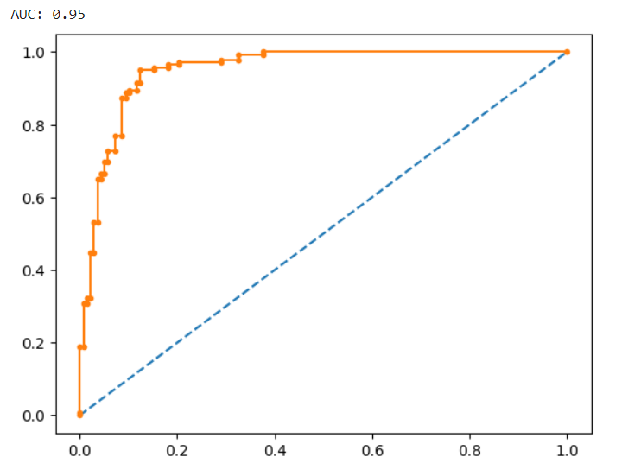
Beyond the immediate benefit of fraud prediction, the integration of such machine learning models into the claims review process can bring substantial business value. Efficient and accurate fraud investigation processes protect the profits of insurance companies, with eventual benefits cascading to consumers through improved risk management and pricing strategies.
Future steps in this endeavor would involve ongoing model tuning and testing on new, unseen claims data. Continuous monitoring of model metrics in the production fraud detection environment would facilitate ongoing enhancements, ensuring real-world performance improvements. Complementary clustering models could also be explored to uncover emerging fraud patterns.
In essence, this project has showcased the high potential for artificial intelligence to make a meaningful impact in mitigating the financial losses incurred each year due to various forms of insurance fraud. The integration of advanced machine learning techniques can revolutionize fraud detection and prevention, ushering in a new era of efficiency and accuracy in the insurance industry.

